Task 3: Networking Basics for Cyber Security

Thirupugal V
ELEVATE LAB INTERNSHIP TAKS

Networking Basics for Cyber Security

Networking forms the backbone of modern digital communication. Every action performed on the internet, such as browsing websites, sending emails, or using mobile applications, involves the transmission of data across networks. In cyber security, understanding how data flows through a network is essential for identifying vulnerabilities, detecting malicious activities, and protecting sensitive information.

This task focuses on learning fundamental networking concepts and analyzing real-time network traffic using packet capturing tools. By observing packets, we can understand how attackers exploit insecure communication and why secure protocols are necessary.

2. Objectives of the Task

The main objectives of this task are:
- To understand basic networking concepts such as IP, MAC, TCP, UDP, DNS, HTTP, and HTTPS.
- To capture live network traffic using Wireshark.
- To analyze different network protocols.
- To identify security risks in unencrypted communication.
- To understand how encryption improves network security.

3. Tools Used

Primary Tool: Wireshark
Operating System: Kali Linux / Linux-based system
Network Interface: Wi-Fi / Ethernet
Wireshark is a widely used packet analysis tool that allows users to capture and inspect network packets in real time.

4. Basic Networking Concepts Studied

IP Address:
An IP address is a logical address assigned to a device in a network. It helps identify the source and destination of data packets.

MAC Address:
A MAC address is a unique physical address assigned to a network interface card (NIC).

TCP (Transmission Control Protocol):
TCP is a connection-oriented protocol that ensures reliable data transfer using error checking and acknowledgment.

UDP (User Datagram Protocol);
UDP is a connectionless protocol that prioritizes speed over reliability.

DNS (Domain Name System):
DNS translates human-readable domain names (like google.com) into IP addresses.

HTTP and HTTPS:
- HTTP: Transmits data in plain text and is not secure.
- HTTPS: Uses encryption to secure data transmission.

5. Methodology (Practical Experiment)

Step 1: Packet Capture
Wireshark was opened, and the active network interface was selected. Live packet capture was started while performing normal internet activities such as browsing websites.

Step 2: DNS Traffic Analysis
Using the display filter dns, DNS query and response packets were analyzed. These packets revealed the domain names accessed and their corresponding IP addresses.

Step 3: HTTP Traffic Analysis
Using the filter http, HTTP packets were observed. Some data was visible in plain text, showing how unencrypted communication can expose sensitive information.

Step 4: HTTPS Traffic Analysis
Using the filter tls, HTTPS packets were analyzed. The data content was encrypted and unreadable, demonstrating secure communication.

Step 5: TCP Three-Way Handshake Observation
TCP packets were filtered using tcp. The three-way handshake process involving SYN, SYN-ACK, and ACK packets was identified, which establishes a reliable connection before data transfer.

Step 6: IP and MAC Address Identification
By selecting individual packets, source and destination IP addresses and MAC addresses were identified from the packet details pane.
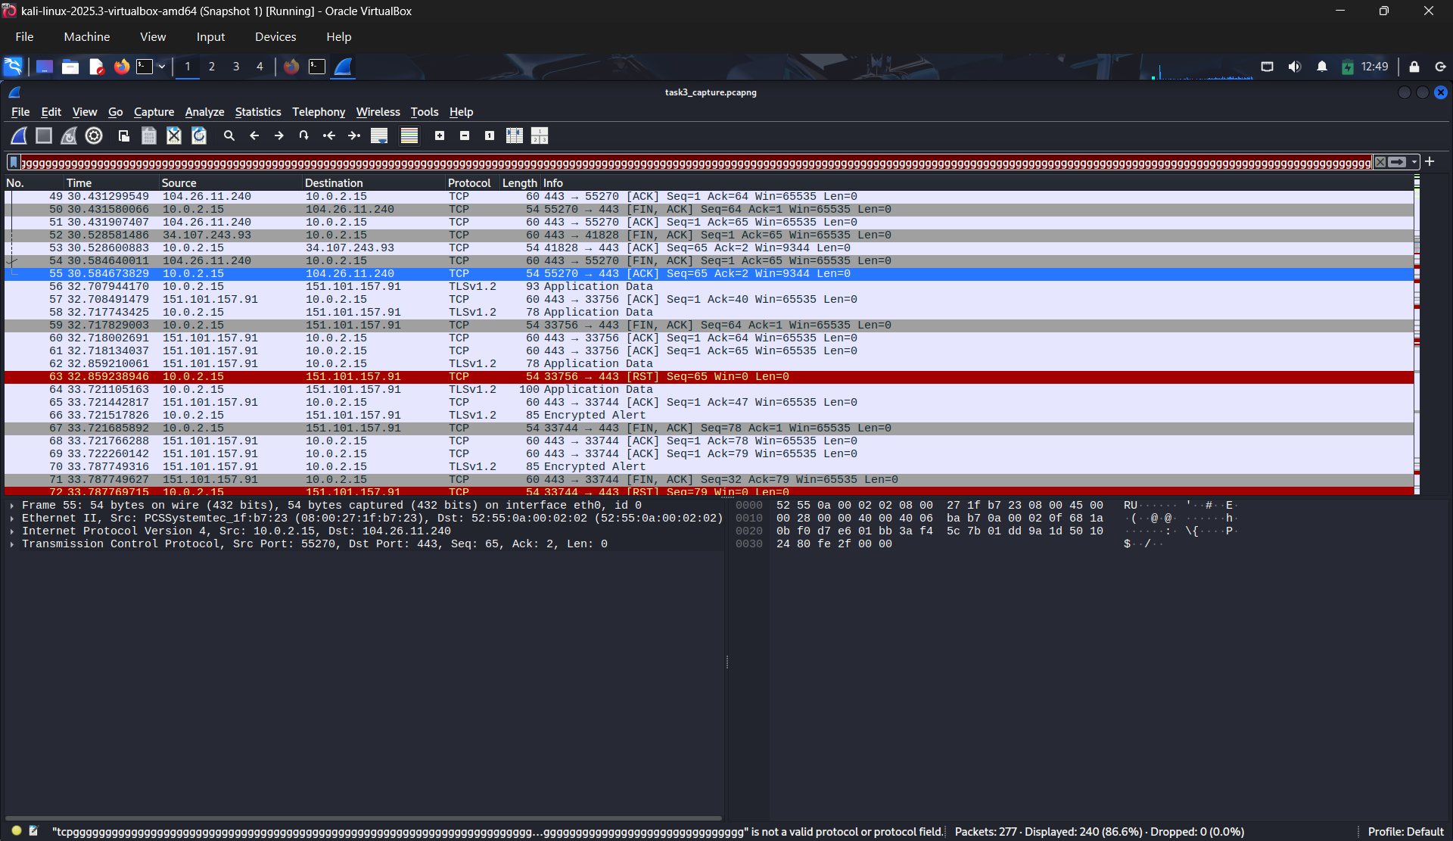

This is the sample of the packet that I have captured and analysised .

6. Observations

- DNS queries reveal the websites visited by a user.
- HTTP traffic transmits data in plain text, making it vulnerable to interception.
- HTTPS encrypts communication, preventing attackers from reading sensitive data.
- TCP ensures reliable communication through its three-way handshake mechanism.
- Packet sniffing can expose network behavior if security measures are weak.

7. Security Analysis
Packet analysis showed that insecure protocols such as HTTP can leak sensitive information to attackers using packet sniffing techniques. DNS traffic can also expose browsing behavior. Encrypted protocols like HTTPS significantly reduce the risk of data exposure. This highlights the importance of using secure communication protocols and encryption to protect user data.

8. Deliverables
Packet Capture File: task3_capture.pcapng
Analysis Report: This document

Conclusion
This task provided hands-on experience in analyzing network traffic and understanding how data flows through a network. By using Wireshark, real-time packets were captured and analyzed, revealing both secure and insecure communication methods. The experiment demonstrated why encryption and secure protocols are essential in cyber security. This knowledge forms a strong foundation for further studies in network security and threat analysis.

